Name: Lakiel Wade

ID: 2601283

Lab Assignment 6

1-2) Write(Create) triggers to implement Constraint EMPDEPTFK in Table Employee based on the following rules as defined in DDL for Employee as in Figure 4.2:

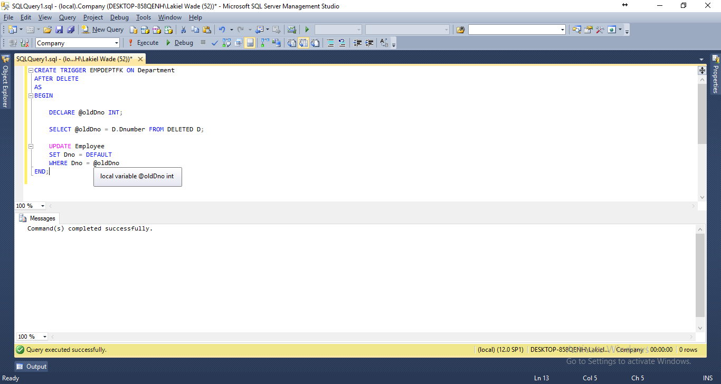

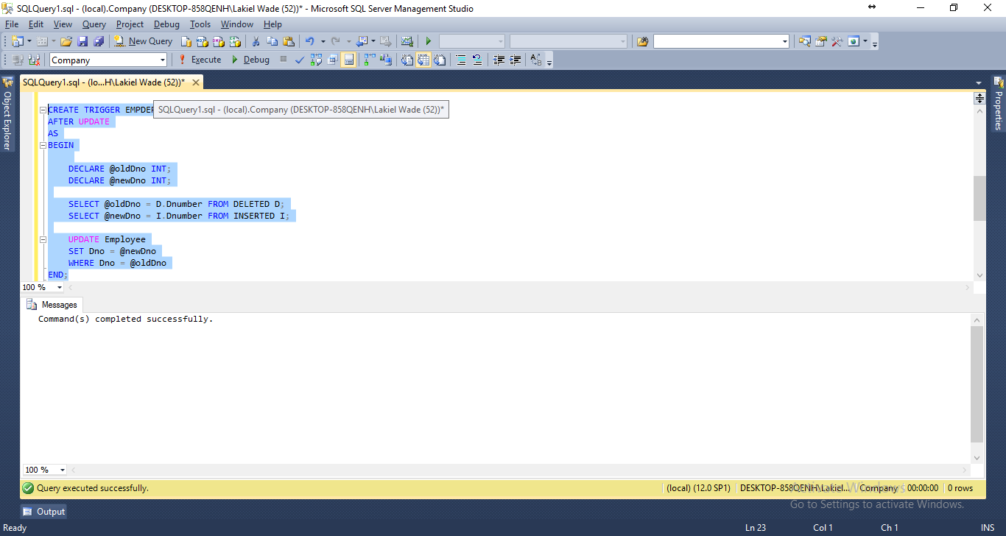

1-3) Write (Create) Stored Procedure SP_Audit_Dept that inserts all the history of the data of changes by the trigger you created in 1) above into a table Audit_Dept_Table. See for the more specific instructions that are given in 2 below.

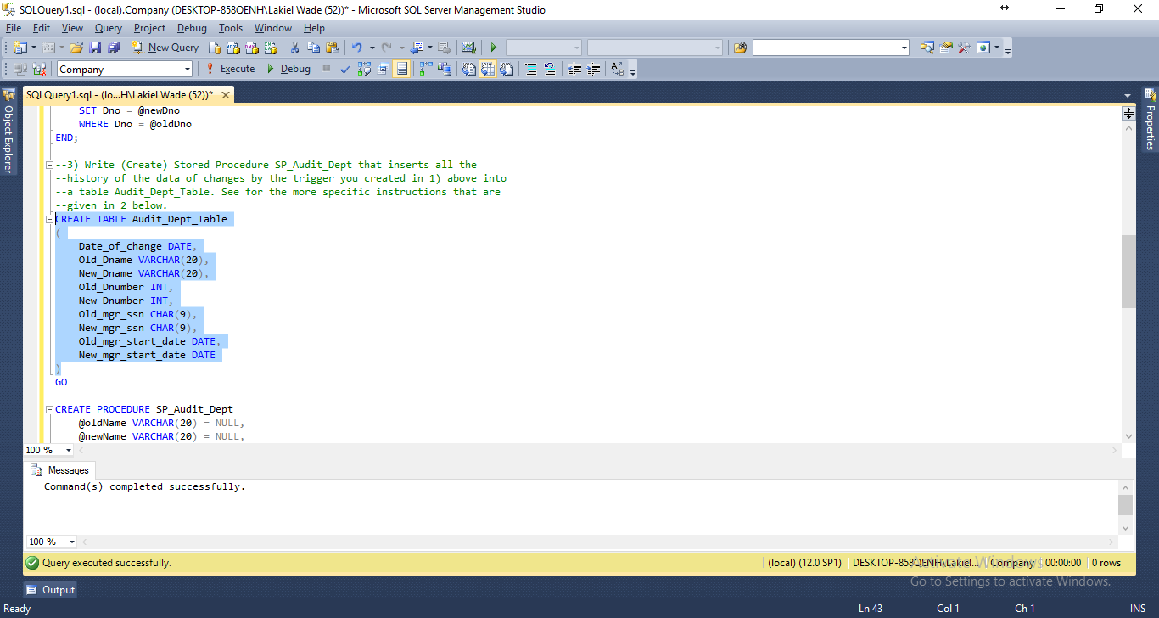

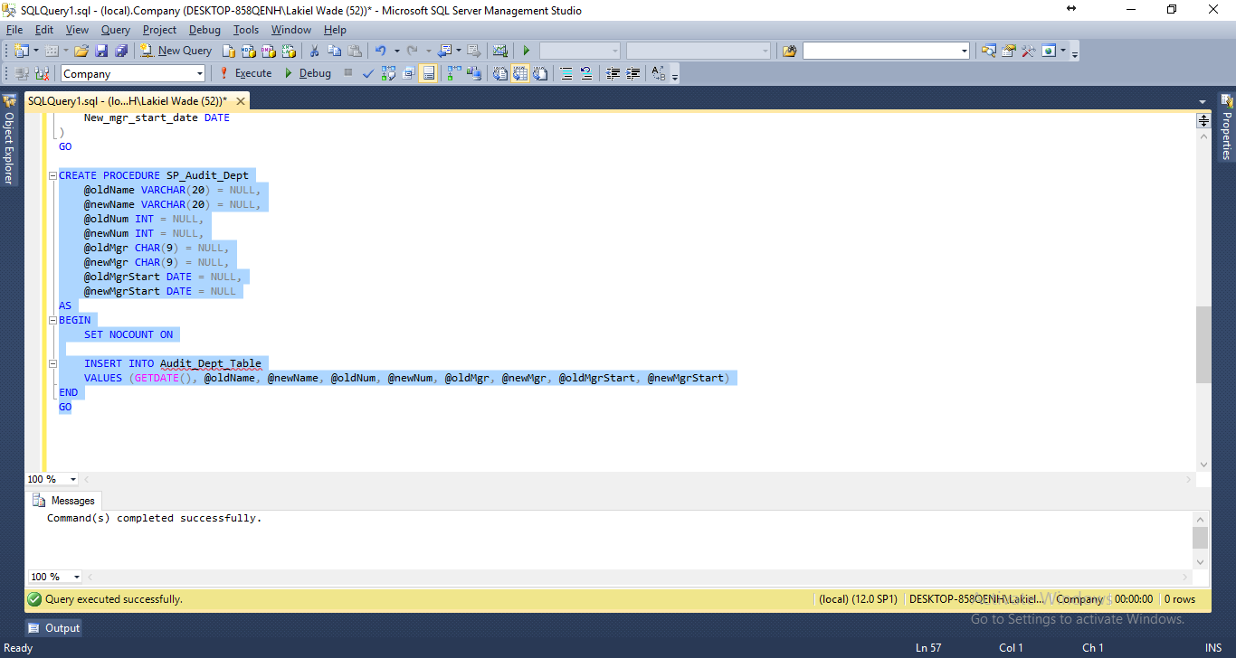

1. On Update of the trigger, Insert the new record into a table named Audit_ Dept_Table as follow:

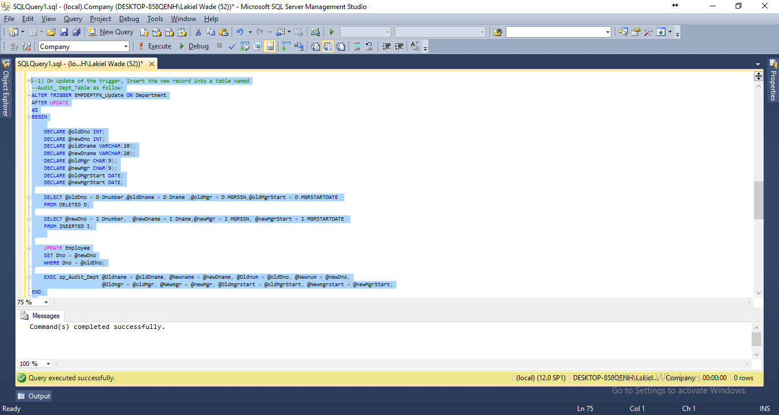

1. On Delete of the trigger, Insert the changes into Audit_ Dept_Table table as well.

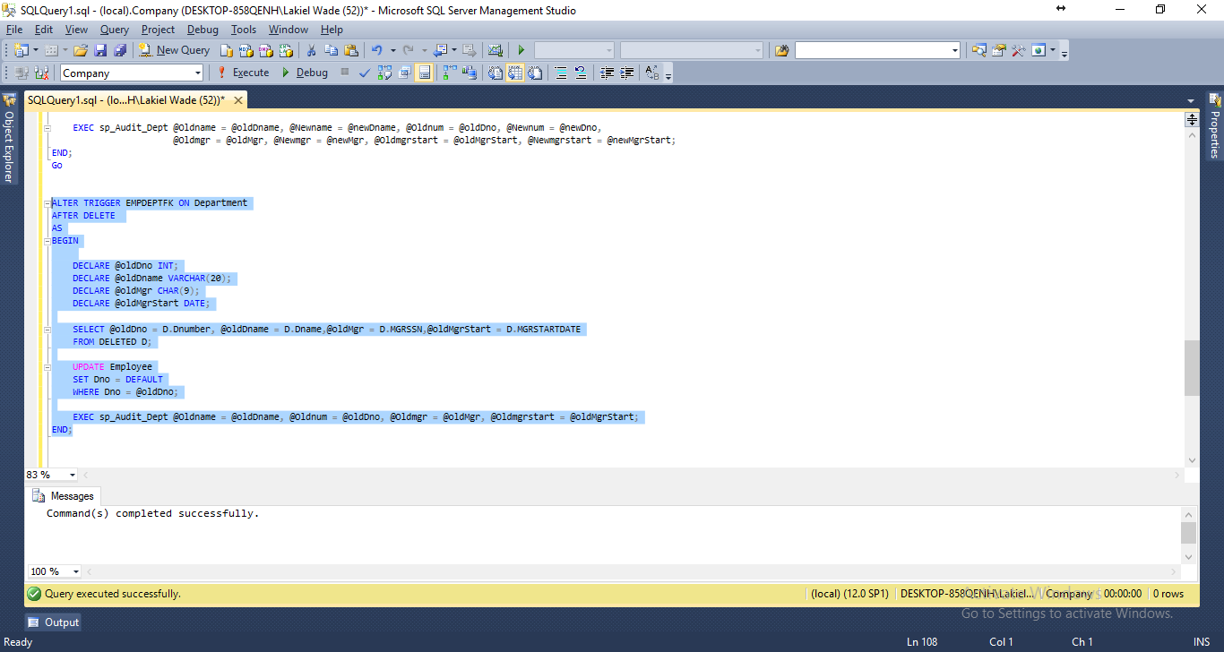

3. Let the Events happen to get each trigger you created fired by executing the following DML on Department Table One at a time:

3a UPDATE Department SET Dnumber = 99 WHERE Dnumber = 4

BEFORE expected results before trigger has occured

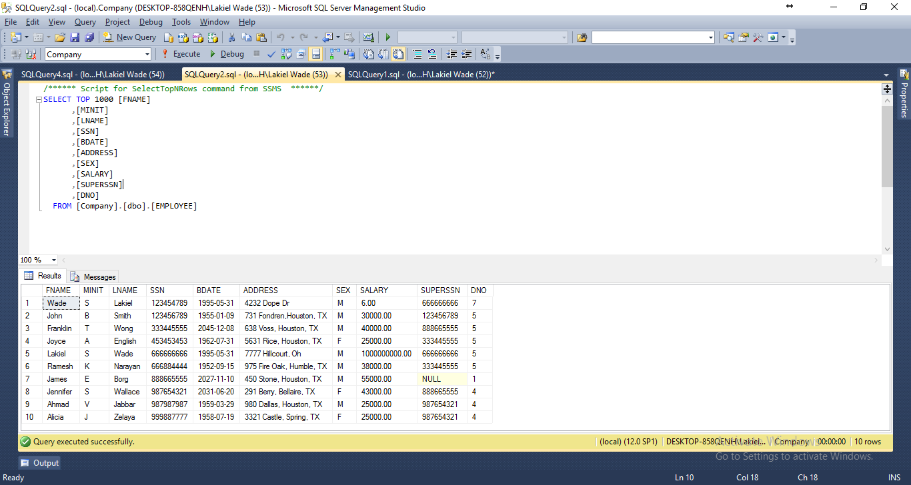

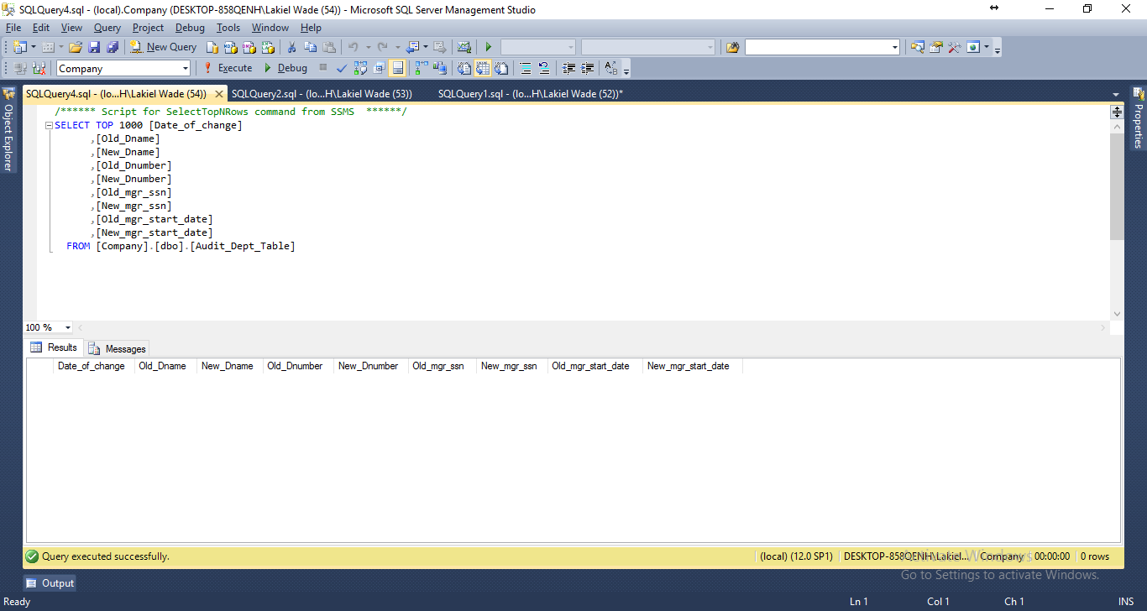

AFTER updated changes has occurred on employee changes for all dno that equaled 4 and a new entry has been inserted to Audit_Dept_Table

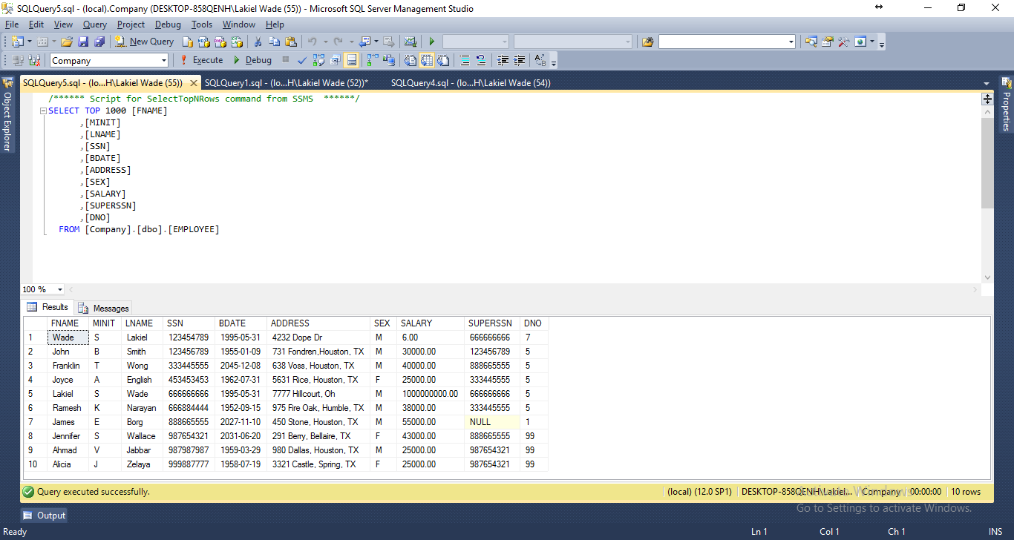

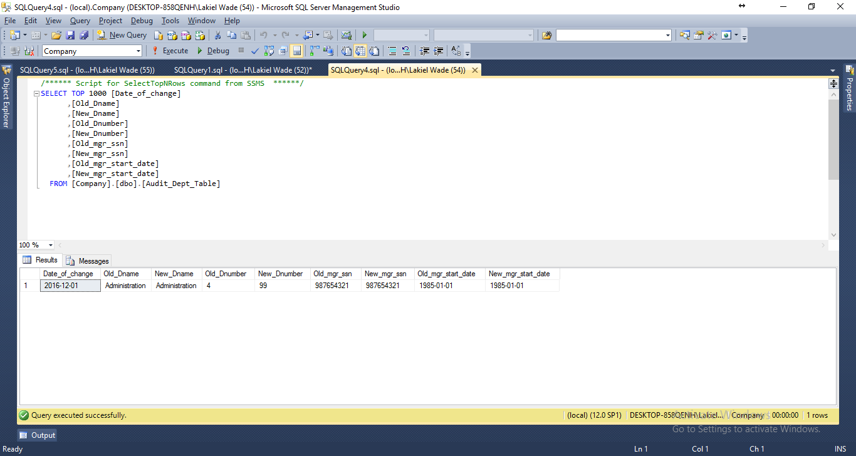

DELETE Department WHERE Dnumber = 5

Before Delete Statement Employee dno is 5 and Audit_Dept_Table has no delete entry

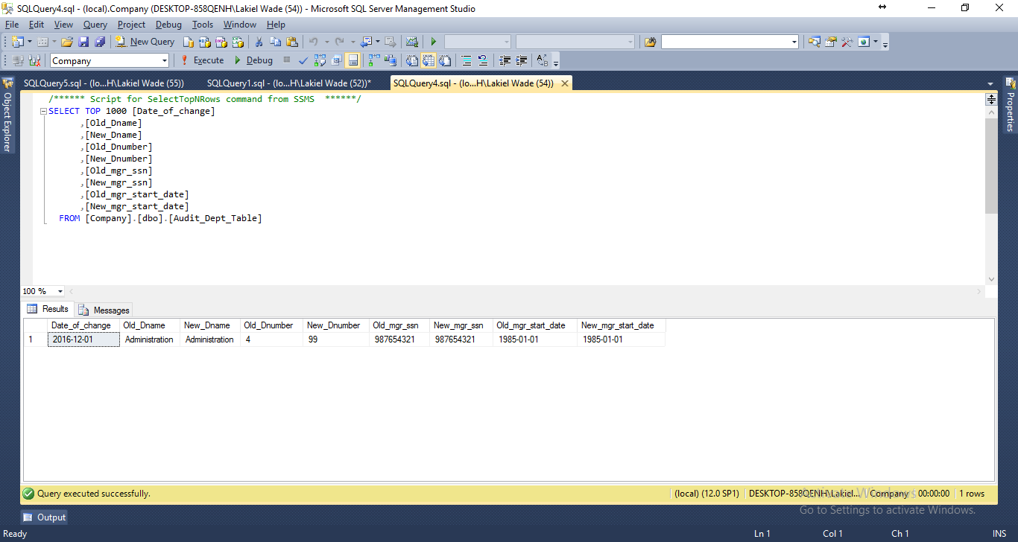

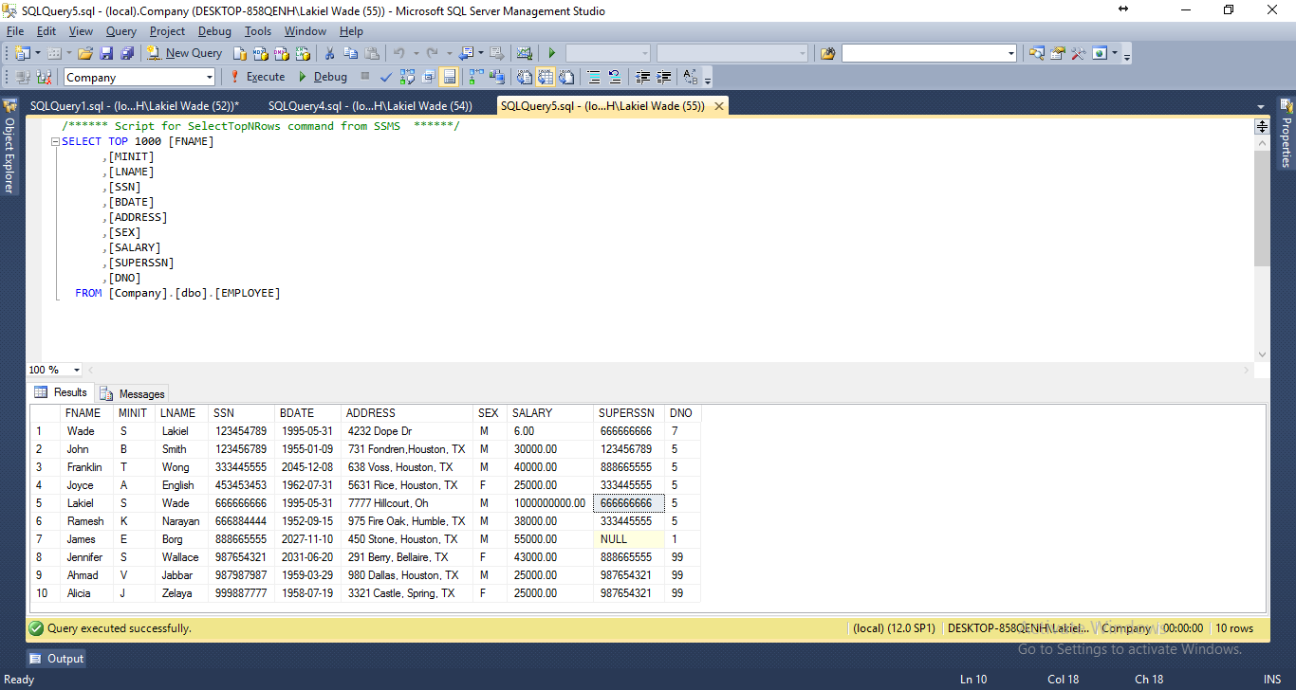

After Audit_Dept_Table has an entry for recently delete tuple and Employee table dno has defaulted to 1 for all that was dno = 5